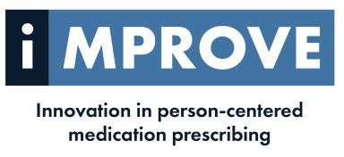
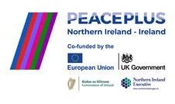
Project Pharmacist- IMPROVE

The Improve project in partnership with the University of Ulster
The objective of the Improve project is to develop, implement and assess a new personalized and person-centric healthcare pathway, optimizing prescribing of common medications in NI (Co Londonderry), Ireland (Co Donegal) and Scotland (Tayside) in primary care.
Novel pharmacogenomic (PGx) testing will embed personalized medicine in a person-centered medication review (MR) process, to enhance prescribing by identifying if an individual’s genetic make-up will alter drug metabolism and therefore i) reduce response to the drug, or ii) increase the risk of ADEs.

LOCATION: Derry GP Federation Area
REPORTING TO: Pharmacy Lead & Derry Federation Board of Directors
Hours Full Time/Part time Hours available
Salary: band 7, £49,387-£56,515 per annum
DURATION: Fixed term contract until September 2028

N.B. Internal secondments will be considered in line with the Federations secondment policy.

CLOSING DATE: Friday 10th April

If you have any queries regarding this post or would like an application pack, please contact hr@westernfsu.co.uk

GP Federation is an equal opportunities employer.

Supported by PEACEPLUS, a programme managed by the Special EU Programmes Body (SEUPB)

