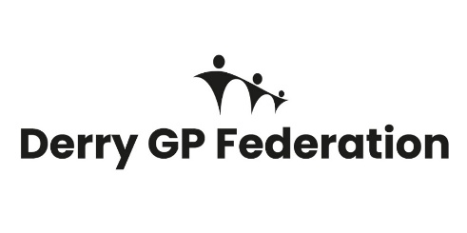
Lead Nurse.
The GP Federation is a collective group of GP Practices across a set geographical area with a common desire to work together at scale, sharing responsibility for the development and delivery of high-quality patient-focused services, closer to home for their local population.
GP Federations provide the opportunity for a single voice of strength from primary care in given geography across Health and Social Care, actively contributing to the evolvement of the transformation agenda.
The Derry GP Federation is established as a Community Interest Company Limited by Guarantee in the not-for-profit sector, with any surplus created to be reinvested for the good of the community it serves locally or wider primary care. It is effectively a management company owned by Member practices, with its core purpose to ensure that clinicians are:
“Free to focus on ensuring they provide the best clinical outcomes for their patients while improving the quality-of-care patients receive”
The GP Federation offers competitive rates of pay, flexible working options, enhanced annual leave, occupational sick pay, company pension, length of service recognition and 24/7 employee assistance programme.
We are now recruiting for a Lead Nurse for the Derry Advanced Nurse Practitioner Workforce
LOCATION: Derry GP Federation Office, Derry

SALARY: £64,455-£74,896 (Band 8B) Pro Rata

HOURS: Part Time, 15 hours per week

CLOSING DATE: Friday 25th September 26.

For more information, please contact hr@westernfsu.co.uk

The GP Federation is an equal opportunities employer.

