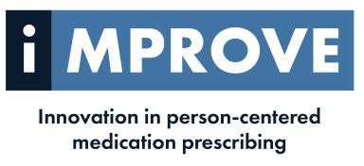

Project Nurse- IMPROVE

The Improve project in partnership with the University of Ulster
The objective of the Improve project is to develop, implement and assess a new personalized and person-centric healthcare pathway, optimizing prescribing of common medications in NI (Co Londonderry), Ireland (Co Donegal) and Scotland (Tayside) in primary care.
Novel pharmacogenomic (PGx) testing will embed personalized medicine in a person-centered medication review (MR) process, to enhance prescribing by identifying if an individual’s genetic make-up will alter drug metabolism and therefore i) reduce response to the drug, or ii) increase the risk of ADEs.

LOCATION: Derry GP Federation Area
ACCOUNTABLE TO: Derry Federation Board of Directors
Hours 37.5 per week
Salary: band 6, £37,338-£44,962 per annum
DURATION: Fixed term contract until September 2028

CLOSING DATE: Friday 10th April

If you have any queries regarding this post or would like an application pack, please contact hr@westernfsu.co.uk

GP Federation is an equal opportunities employer.

Supported by PEACEPLUS, a programme managed by the Special EU Programmes Body (SEUPB)

