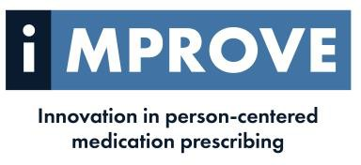
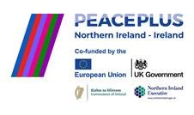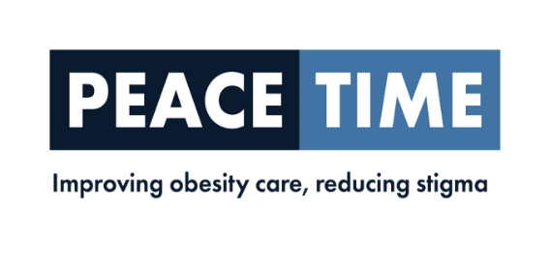
Project Administrative Assistant
The Derry GP Federation is seeking to recruit a Project Administrative Assistant to support the development of the PEACETIME & IMPROVE research projects which are being operated in partnership with the University of Ulster
LOCATION: Derry GP Federation Area
ACCOUNTABLE TO: Derry Federation Board of Directors
Hours 37.5 per week (part-time working may be considered)
Salary: band 3- £24,937-£26598 per annum
DURATION: Fixed term contract until September 2028
The role of the Project Administrative Assistant is to support all aspects of the project and work with the Lead Partner, University of Ulster and other project partners to achieve project outcomes

CLOSING DATE: 11th September 2026

If you have any queries regarding this post or would like an application pack, please contact hr@westernfsu.co.uk

Derry GP Federation is an equal opportunities employer.

Supported by PEACEPLUS, a programme managed by the Special EU Programmes Body (SEUPB)

