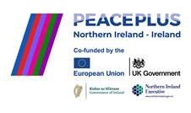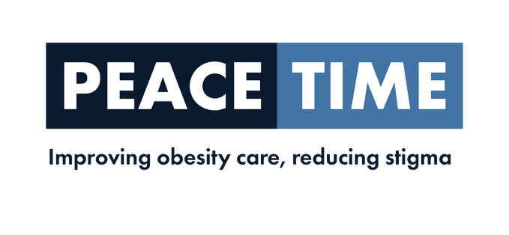
Lead Dietician- PEACETIME

Objective of the PEACETIME Project
Development of a specialist obesity management service for adults with type 2 diabetes in primary care and the community in the Northwest.
The overall objective of PEACETIME is the development and evaluation of a novel integrated cross border clinical service that will increase access to care for people living with OBDM. The clinical model will be based on existing primary care and community structures, thereby ensuring equitable access to health care and fostering resilience of the healthcare system in the Northwest of Ireland
Project Partners:
- Lead Partner – University of Ulster
- Atlantic Technological University
- Irish Coalition for People Living with Obesity
- National Institute for Preventative and Cardiovascular Health
- Derry GP Federation
The Derry GP Federation is seeking to recruit a Lead Dietician to support the development of the PEACETIME Obesity Project.

LOCATION: Derry GP Federation Area
ACCOUNTABLE TO: Derry Federation Board of Directors
Hours 37.5 per week
Salary: band 7 £47,810-£54,710 per annum
DURATION: Fixed term contract until September 2028

The role of the lead Dietician PEACETIME is to support all aspects of the project and work with the Lead Partner, University of Ulster and other project partners to achieve project outcomes

CLOSING DATE: Friday 8th May

If you have any queries regarding this post or would like an application pack, please contact hr@westernfsu.co.uk

GP Federation is an equal opportunities employer.

Supported by PEACEPLUS, a programme managed by the Special EU Programmes Body (SEUPB)

