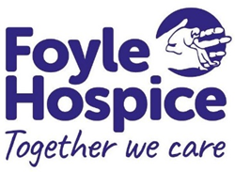
Community Nurse Specialist in Palliative Care Omagh and Fermanagh Localities
(Band 6 and Band 7, Agenda for Change pay scale)
Current posts available: 30 hours permanent 4-day week and 15 hours permanent 2-day week.

Foyle Hospice has an immediate vacancy for a Community Nurse Specialist in Palliative Care to deliver expert end of life care to those with complex palliative/end of life needs in their own homes and care homes.
The successful candidate will be a registered Nurse on Part 1 (Adult) of the live NMC Register with a Specialist Practice Degree in Palliative Care or currently undertaking with completion of this course in 2024. Three year’s post-registration experience caring for patients with cancer/palliative care or haematology needs in a health care setting is also required.
If you do not hold a Specialist Practice Degree in Palliative Care you must be willing to undertake this course following appointment and until graduated will work as a Community Palliative Care Nurse Band 6.
A waiting list will also be created for any permanent, temporary, full time, part time and Bank vacancies which may arise over the next year.
For an application pack contact:
Patricia Ferguson
Human Resources Administrator
Foyle Hospice
61 Culmore Road
Derry - Londonderry
BT48 8JE
Telephone: 028 71 351010
Email: hr@foylehospice.com
Closing date for the receipt of completed applications is: 24th January 2024 at 12pm. Interviews will be held on: 13th February 2024. Please note that late applications will not be considered.
Foyle Hospice is an Equal Opportunities Employer

