Application Form
Applicant Ref:
(office use only)
AN EQUAL OPPORTUNITIES EMPLOYER
Job Ref Number: GPNT/2026/17
Job Title: General Practice Nurse Training Programme
Federations: Ards & West Belfast GP
Federations

Closing Date: 12 noon on Friday 15th May 2026

NOTES:
• CVs will not be accepted
• Canvassing will disqualify
• Incomplete applications will not be considered
• You are strongly encouraged to complete the equal opportunities section of this form which is used only
for monitoring/statistical purposes and is not made available to the panel
• Applications received after the closing date and time
will not be considered
- Applications must be completed and returned electronically

Surname: |  |  | Title (Mr, Mrs, Miss, Ms, Dr):
First Names: |  |  | Previous Surname:
Address:
Postcode:
Contact Number: |  |  | National Insurance:
Email Address:

Do you hold a current full driving licence valid in the UK? Yes No
If required, do you have access to a car, or a form of transport Yes No
which will enable you to undertake the duties of this post?
Please name two referees – as per application pack, who will only be contacted at job offer stage.

Title (Mr, Mrs, Miss, Ms, Dr): Title (Mr, Mrs, Miss, Ms, Dr):
Name: Name:
Occupation: Occupation:
Address: Address:

Postcode: Postcode:
Phone No: Phone No:
Email: Email:

FURTHER EDUCATION/ PROFESSIONAL QUALIFICATIONS
(e.g. Nursing, AHP, Social Care, Management, Administration)

Certificate/Diploma/Degree | Institute | Exams yet to be taken | Result | Date Obtained
PROFESSIONAL QUALIFICATIONS
Name of Professional Body | Type of Registration | Professional Registration No. | Date Obtained | Date of Expiry
Are you currently the subject of a referral to, or an investigation by, your professional body?
Yes No Not Applicable
Have you been involved or are you currently involved in any professional or personal, unresolved or pending issue that might undermine your standing ability to do the job?
Yes No
INDEPENDENT SAFEGUARDING AUTHORITY

Have you ever been referred to the Independent Safeguarding Authority as a result of misconduct involving children and / or vulnerable adults? Yes No

If yes, please provide full details below:

EMPLOYMENT HISTORY – PRESENT OR MAIN POST
Employer Name: Period of Notice:
Employer Address: Salary / Wage:
Job Dept / Location:
Start Date:
Job Title: Reason for Leaving:
Employment Status: Permanent Temporary Agency
Principle Duties of the Present Post:
EMPLOYMENT HISTORY — PREVIOUS POSTS
Please list all your most recent previous posts beginning with the most recent.

Name and Address  of Employer | Job Title | Start  Date | End  Date | Reason for Leaving | Duties

If you have any gaps in your career history, please include and explain these in the box below.

ESSENTIAL CRITERIA
You must demonstrate evidence of the following essential criteria by way of examples and dates in the box below. Please note the maximum word count is 300 words.
- Essential Criteria 1: Registered Nurse Adult: First level, on the NMC register.

ESSENTIAL CRITERIA
You must demonstrate evidence of the following essential criteria by way of examples and dates in the box below. Please note the maximum word count is 300 words.
- Essential Criteria 2: 1 year’s post registration experience.

ESSENTIAL CRITERIA
You must demonstrate evidence of the following essential criteria by way of examples and dates in the box below. Please note the maximum word count is 300 words.
- Essential Criteria 3: Applicants must demonstrate full understanding of the current NMC Code and Scope of Professional Practice.

ESSENTIAL CRITERIA
You must demonstrate evidence of the following essential criteria by way of examples and dates in the box below. Please note the maximum word count is 300 words.
- Essential Criteria 4: Applicants must demonstrate sound clinical knowledge of current nursing practice.

ESSENTIAL CRITERIA
You must demonstrate evidence of the following essential criteria by way of examples and dates in the box below. Please note the maximum word count is 300 words.
Essential Criteria 5: Applicants must be able to demonstrate IT literacy including the ability to use MS Office and/or other relevant systems, providing examples of this.

ESSENTIAL CRITERIA
You must demonstrate evidence of the following essential criteria by way of examples and dates in the box below. Please note the maximum word count is 300 words.
Essential Criteria 6:
Full current driving licence (valid in the UK) and have access to a car at the closing date or have **access to a form of transport which will permit the Applicant to carry out the duties of the training post in full.

**This relates only to any person who has declared that they have a disability that debars them from driving.

DISABILITY
If you require a reasonable adjustment for reasons related to a disability to allow you to attend interview, please contact recruitment@easternfsu.co.uk.

PERSONAL DECLARATION

1. I declare that all the foregoing statements are true, complete and accurate
2. I understand that if I give wrong information or leave out important information I could be dismissed if I take up this job
3. I understand that to take up this job I must have satisfactory references, health assessment and Access NI checks (if applicable)
4. I understand that I will be asked to show some formal identification and evidence of qualifications if required
5. I confirm that as far as I know there are no medical reasons which would stop me from carrying out the duties of this job
6. I agree to you making any necessary enquiries during the recruitment and selection process
7. I understand that canvassing will disqualify me from the selection process for this job
8. I consent to the information I have provided being used within the context of the Data Protection Act 1998
9. I know of no reason why I cannot work in regulated activity.
Your Signature: Date:

Please indicate how you became aware of this vacancy:
Social Media Professional Radio
Newspaper, please specify Other, please specify
NIjobfinder NIjobs.com

Employee/ Applicant Monitoring Questionnaire
PLEASE COMPLETE AND RETURN SEPARATELY FROM YOUR APPLICATION FORM TO recruitment@easternfsu.co.uk, MARKING YOUR EMAIL as “CONFIDENTIAL”
Private & Confidential
Job Title: General Practice Nurse Training Programme

Ref No: GPNT/2026/17
We are an Equal Opportunities Employer. We do not discriminate our job applicants or employees and we aim to select the best person for the job. We monitor the community background and sex of our job applicants and employees in order to demonstrate our commitment to promoting equality of opportunity in employment and to comply with our duties under the Fair Employment & Treatment (NI) Order 1988.
You are not obliged to answer the questions on this form and you will not suffer any penalty if you choose not to do so. Nevertheless, we encourage you to answer these questions. Your answers will be used by us to prepare and submit a monitoring return to the Equality Commission, but your identity will be kept anonymous. In all other regards your answers will be treated with the strictest confidence. We assure you that your answers will not be used by us to make any decisions affecting you, whether in a recruitment exercise or during the course of any employment with us.

- Community Background

Regardless of whether they actually practice religion, most people in Northern Ireland are perceived to be members of either the Protestant or Roman Catholic communities.

Please indicate the community to which you belong by ticking the appropriate box below:

I am a member of the Protestant community

I am a member of the Roman Catholic community

I am not a member of neither the Protestant nor Roman Catholic community

If you do not answer the above question, or if you tick the “not a member of either box”, we are encouraged to use the residuary method of making a determination, which means that we can make a determination as to your community background on the basis of the personal information supplied by you in your application form/personnel file.

- Sex

Please indicate whether you are: Female Male
Note: If you answer this questionnaire you are obliged to do so truthfully as it is a criminal offence under the Fair Employment (Monitoring) Regulations (NI) 1999 to knowingly give false answers to these questions.
- Age
Please state your date of birth (dd/mm/yyyy):

Date of Birth:

- Racial Group
Please state your country of birth:
My nationality is:

Please indicate which of the following applies to you:

White Chinese

Irish Traveller

Indian Pakistani

Bangladeshi Black African

Black Caribbean
Black Other

Mixed ethnic group (please state which):
Any other ethnic group (please state which):

- Disability
Under the Disability Discrimination Act 1995 you are deemed to be a disabled person if you have cancer, multiple sclerosis or HIV infection.

Also, you are deemed to be a disabled person if you have a physical or mental impairment which has a substantial and long-term adverse effect on your ability to carry out normal day-to-day activities.

Do you consider that you are a disabled person?

Yes: No:

If you answered “yes”, please indicate he nature of your impairment by ticking the appropriate box or boxes below:

Physical impairment, such as the difficulty using your arms, or mobility issues requiring you to use a wheelchair or crutches:

Sensory impairment, such as being blind or having a serious visual impairment, or being deaf or having a serious hearing impairment:

Mental health condition, such as depression or schizophrenia:

Learning disability or difficulty, such as Down’s Syndrome or dyslexia, or Cognitive impairment, such as autistic spectrum disorder:

Long-standing or progressive illness or health condition, such as cancer, HIV infection, diabetes, epilepsy or chronic heart disease:

Other (pleased specify):

- Sexual Orientation

Please indicate your sexual orientation by ticking the appropriate box below:

My Sexual Orientation is:

I am straight:

I am gay or lesbian:

I am bisexual:

- Marital Status/ Civil Partnership Status
Please indicate whether you are married or in a civil partnership by ticking the appropriate box below:
Are you married or in a civil partnership?
Yes: No:

- Dependents/ Caring Responsibilities

Do you have dependents, or caring responsibilities for family members or other persons?

Yes: No:

If you answered “yes” are your dependents or the people you look after?
(Please tick the appropriate box or boxes):

A child or children:

A disabled person or persons:

An elderly person or persons:

Other:

If “Other), please specify:

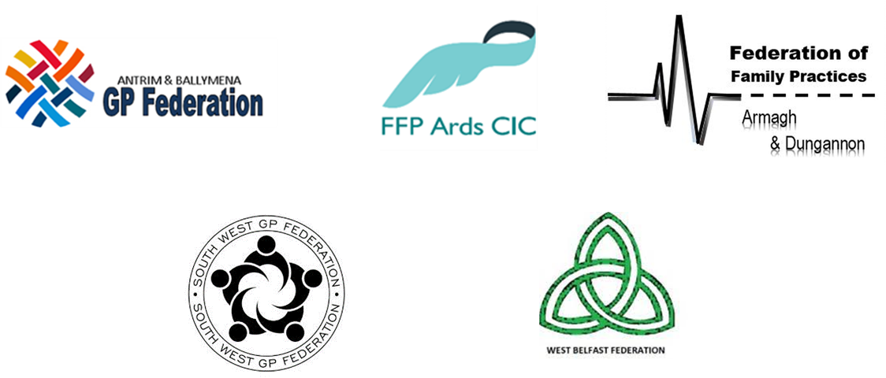

Applicant no.: GPNT/2026/17 __ __ __

Recruitment Preference Sheet

Job Title: General Practice Nurse Training
Programme

Reference: GPNT/2026/17

Applicant Name: ________________________________________

Please indicate which posts you would like to be considered for:

- Federation of Family Practices Ards - General Practice Nurse
(Training Programme) Permanent Post

Federation of Family Practices West Belfast - General Practice Nurse (Training Programme) Permanent Post

Please refer to the Applicant Information Pack for information relating to geographical areas within each Federation Area.

Please return this form with your application form and equal opportunities monitoring form.

