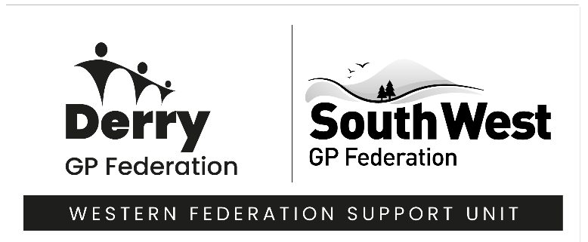

Derry GP Federation

Administrative Assistant

Location – Derry/Londonderry

Salary - £24,071- £25,674 (Band 3)

Hours – 37.5 hours per week

Status –Full time – 2-year fixed term contract.

GP Federations are not-for-profit Community Interest Companies consisting of GP practices in defined areas. The primary objective of each individual Federation is to support GP Practices and provide better care, delivered in a more responsive way and closer to home, for all our patients. This focuses on working across the local health and social care community, in collaboration with a wide number of agencies, in seeking to design and implement innovative healthcare strategies and ways of delivering high quality care.

GP Federations are supported by a Federation Support Unit (FSU) which provides service in areas such as Finance, Human Resources and Payroll. The Western Federation Support Unit now seeks to recruit an Administrative Assistant to work as an integral part of our growing team providing high quality routine administrative support to the Derry GP Federation. Post will be based in Derry.

Applications are invited for the following 1 full-time post 2-year fixed term contract

Administrative Assistant – Job Summary

- Provide high quality routine administrative support ensuring the effective operation of systems and procedures including the maintenance of all files and correspondence as necessary.

- Manage the diary, room bookings and set up meetings on behalf of the Derry Federation

- To act as the first point of contact in respect of telephone enquiries and provide advice where appropriate.
- Provide general office/Secretarial duties when required, including typing, answering the telephone, photocopying, filing and other duties.

- Maintain supplies inventory by checking stock to determine inventory level; anticipating needed supplies; placing and expediting orders for supplies; verifying receipt of supplies.

- Effectively prepare reports, documents, and proposals for senior staff within the Federation as well as supplying advice and assistance as required.

- Service Federation and FSU meetings; including scheduling meeting rooms, assisting with the provision of refreshments for internal meetings & the provision of agendas and papers, taking minutes and preparing associated documentation. Please note some of these meetings will be outside of normal working hours.

- Carry out Estates Officer duties for the Derry Federation Offices including but not limited to carrying out of required risk assessments, arranging repairs, ordering of equipment, fire warden duties, arrange regular testing for electrical equipment, ensure the building meets workplace health & safety requirements.

For more information and an application form, email hr@westernfsu.co.uk quoting AADF1225.

Closing Date for completed applications: 9th January 2026 at 12 noon. Please note we will not accept late applications.

WE ARE AN EQUAL OPPORTUNITIES EMPLOYER

